Stand Alone Stations Wall Mount Stations
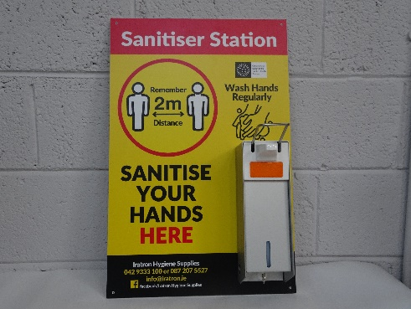
SFSTND1 SFSTND2 WMS1 WMS2
Single Sided (Stand Alone) Single Sided (Wall Mounted)

Measurements: 1260x450mm Measurements: 400x610mm
TFSTND2 TFSTND1
Double Sided

Measurements: 1260x450mm
Covid Wall Signs Covid Stickers Kit
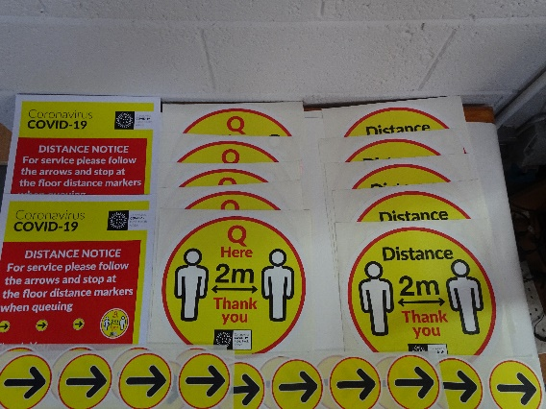
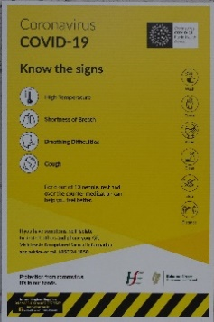
WS1 COVIDKIT

Measurements: 600x450mm 10 x Floor Stickers
2 x Wall Stickers
20 x Arrow Stickers
Roll of 3” Distance Stickers Distance Sticker 12” Round (Single)
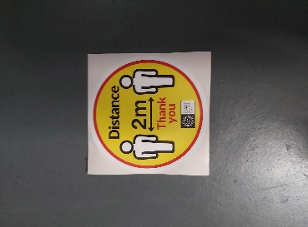
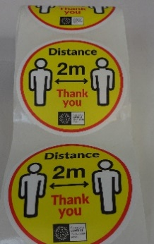

RDS1 DS1

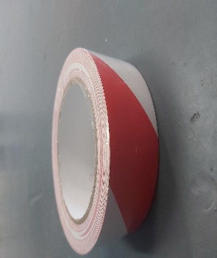
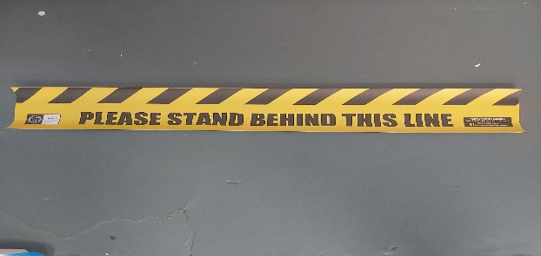
Wait Here Floor Sticker Red Hazard Tape
Insert Pic

Part No.: WH1

Part No.: WH1 Part No.: HWTRW

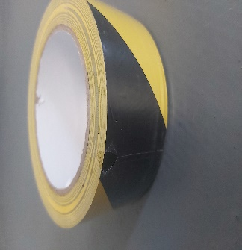
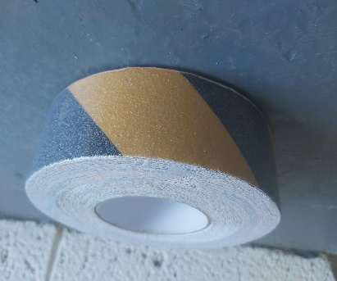
Hazard Tape Anti Slip Hazard Tape

Part No.: HWTBY Part No.: AT38

Refill Spray Bottles
.5L Hozelock Spray Bottles (Repeat Use) Part No.: HZ4120P0000

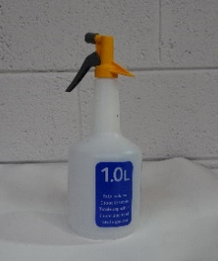
1L Hozelock Spray Bottles (Repeat Use) Part No.: HZ4121P0000

Hand Sanitiser
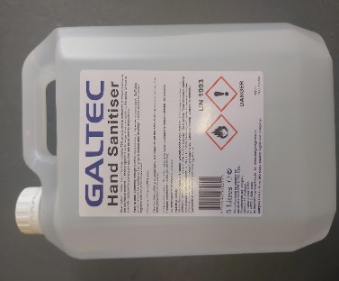
5L Hand Sanitiser Liquid – 70% Alcohol Part No: BC1164

5L Hand Sanitiser Gel – 65%+ Alcohol Part No: BC1174

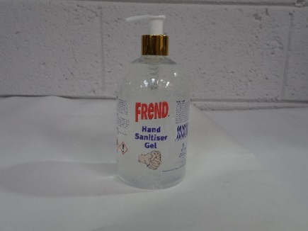
300ml Hand Sanitiser 500ml Hand Sanitiser

Part No.: BC0159 Part No.: BC0158

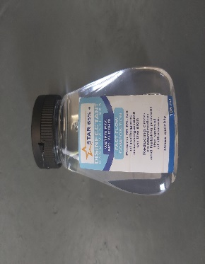
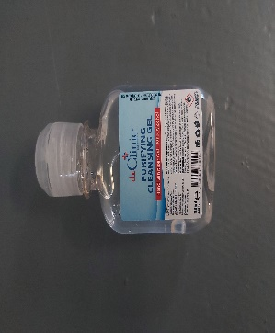
185ml Hand Sanitiser 100ml Hand Sanitiser Gel

Part No. HS185ml Part No. HS100ml

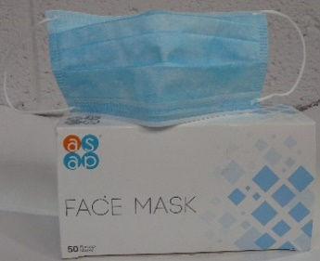
5Ltr Luxury Hand Soap Surgical Blue Face Mask (Single)
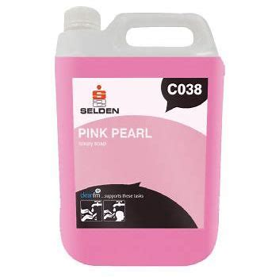

Part No.: BB0125 Part No.: 30011mask

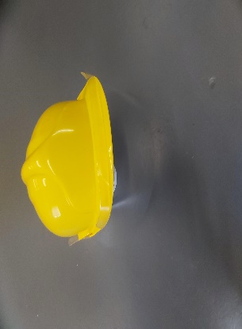
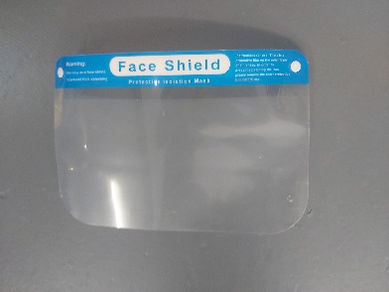
Face Shield Hard Hat Shield

Part No.: FS Part No.: HHFS

Ever Build Antibacterial Wonder Wipes Blue Rolls 2ply Centrefeed
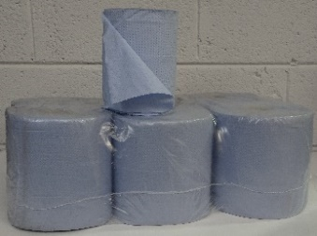

Part No.: Wipes Part No.: W0346
100 Perforated Antibacterial Wipes (Feeder Tub)

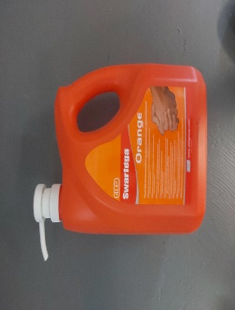
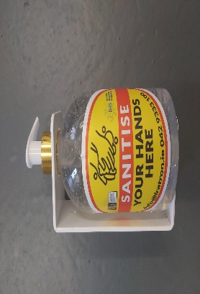
4L Swarfega hand cleaner Wall bracket for bottle

Part No.: SOR4LMT Part No.: SWB1

